

DAEN 690

Project Report

Akarsh Matlaparthi: Scrum Master

Pooja Vemuri: Product Owner

Abhista Atchutuni: Developer

Venkata Naga Sanjay Reddy: Developer

Manikanteswar Gandrothula: Developer

Charan Reddy Thamma: Developer

Spring 2025

Socioeconomic Vulnerability Index for Adaptation to Rising Seas (SOVIARS)

**About the Cover**

The cover of this report reflects the critical challenges facing Puerto Rico, where the effects of rising sea levels and socioeconomic inequalities intersect. The image showcases a vulnerable coastal community, highlighting the threats of flooding, storm surges, and coastal erosion. As sea levels continue to rise, the risk to homes, public infrastructure, and livelihoods grows, creating long-term challenges for many residents.

The cover’s design draws attention to the human side of climate change by emphasizing the struggles faced by low-income communities living in high-risk areas. These neighborhoods, often built along fragile coastlines, are depicted with aging homes and inadequate infrastructure, reflecting their limited ability to cope with or recover from natural disasters. For many of these residents, relocation or rebuilding is not a feasible option, trapping them in a cycle of ongoing vulnerability.

This cover encapsulates the core mission of the SOVIARS project, which aims to guide resource allocation and adaptation planning by prioritizing both environmental and socioeconomic factors. By using detailed geospatial data and vulnerability analysis, the project identifies communities in need of immediate support and long-term investments. The visual imagery also serves as a symbol of resilience, underscoring the idea that, with the right strategies and data-driven insights, communities can be better protected and prepared for future challenges.

Overall, the cover reminds us that effective solutions for rising seas must go beyond technical fixes and infrastructure improvements. They require a human-focused approach that considers the needs of vulnerable populations, ensuring that adaptation plans address not only physical risks but also the social and cultural well-being of affected communities. The SOVIARS project is dedicated to helping Puerto Rico build a future where no community is left behind.

Contents

Table of Contents

Abstract 1

Section 1: Introduction 3

1.1 Report Purpose 3

1.2 Report Readership 3

1.3 Report Structure 4

Section 2: Problem Definition 4

2.1 Problem Space 4

2.2 Research 6

2.3 Solution Space 7

2.4 Project Objectives 7

2.5 Primary User Stories 7

2.6 Product Vision 8

2.6.1 Scenario #1 8

2.6.2 Scenario #2 8

Section 3: Datasets 8

3.1 Overview 8

3.2 Field Descriptions 9

3.3 Data Context 10

3.4 Data Conditioning 10

3.5 Data Quality Assessment 10

3.6 Other Data Sources 11

3.7 Storage Medium 11

3.8 Storage Security 11

3.9 Storage Costs 11

Section 4: Select Section Title Based on Project Type 12

4.1 Algorithms and Analysis 12

4.1.1 Algorithms 12

4.1.2 Analysis 12

4.2 Machine Learning Model Exploration and Selection 13

4.2.1 Model Exploration 13

4.2.2 Model Selection 13

4.3 Solution Approach 13

4.3.1 Systems Architecture 13

4.3.2 Systems Security 13

4.3.3 Systems Data Flows 13

Section 5: Select Section Title Based on Project Type 13

5.1 Visualizations 14

5.1.1 Visualizations and Interpretations 14

5.2 Machine Learning Model Training, Evaluation, and Validation 14

5.2.1 Model Training 14

5.2.2 Model Evaluation 14

5.2.3 Model Validation 14

5.3 Testing and Validation 15

5.3.1 Testing 15

5.3.2 Validation 15

Section 6: Findings 15

Section 7: Summary 15

Section 8: Future Work 15

Appendix A: Domain Background 17

Appendix B: Glossary 18

Appendix C: GitHub Repository 19

Overview 19

GitHub Repository Link 19

GitHub Repository Contents 19

Appendix D: Risks 20

Sprint 1 Risks 20

Sprint 2 Risks 20

Sprint 3 Risks 21

Sprint 4 Risks 21

Sprint 5 Risks 22

Appendix E: Agile Development 24

Scrum Framework Team Approach 24

Sprint 1 Lessons Learned 24

Sprint 2 Lessons Learned 25

Sprint 3 Lessons Learned 25

Sprint 4 Lessons Learned 25

Sprint 5 Lessons Learned 26

Works Cited 27

Table of Figures

Figure 1: ChatGPT is the latest Natural Language Processing tool for Data Analytics. 5

Figure 2: Data Analytics Engineering has the power to be transformative for an organization. 6

Figure 3: Sprint project dates. 24

Table of Tables

Table 1: Glossary Table 18

Table 2: Sprint 1 Risks 20

Table 3: Sprint 2 Risks 21

Table 4: Sprint 3 Risks 21

Table 5: Sprint 4 Risks 22

Table 6: Sprint 5 Risks 22

**This page intentionally left blank**

Abstract

Puerto Rico is increasingly vulnerable to sea level rise impacts, estimated at more than 6.8 feet in 2100 under high-emission scenarios. This risk poses significant threats to coastal populations, infrastructure, and public health, particularly to low-income and socially exposed populations. Despite this, current adaptation plans address economically relevant zones at the expense of the most poorly adapted zones. Furthermore, most of the available literature concentrates on economic losses without taking into consideration the combined effects of environmental exposure and social vulnerability. The SOVIARS Index is a composite index that integrates the Social Vulnerability Index (SOVI) and the Vulnerability to Rising Seas (VRS) component. The SOVI provides an understanding of community sensitivity based on social and economic factors. The VRS component is an assessment of the geographic distribution of people exposed to projected sea level rise and associated flood risk. When combined, these two components of the SOVIARS Index provide a clear picture of the kind of society, the kinds of people who are vulnerable to rising seas. The Index was created by first sourcing data from several organizations, including the U.S. Census Bureau, FEMA, and NOAA. In this project and using QGIS software, we identified areas at or below seven feet of elevation and overlaid them with FEMA flood zones. We then calculated the population densities of the affected areas and combined the results with normalized social indicators to create our final scale. We developed a data integration pipeline to automate the merging of spatial and tabular data, ensuring consistency and reproducibility; and made interactive dashboards and data visualizations to present our findings in a format accessible to policymakers and planners. By emphasizing equity, resilience, and spatial analysis, the SOVIARS framework can thus assist in the allocation of resources for Puerto Rico's long-term climate change adaptation planning and ensures that the most vulnerable populations are prioritized in response strategies.

**This page intentionally left blank**

Report

# Introduction

Rising sea levels, intensified by climate change, pose a significant threat to Puerto Rico’s coastal ecosystems, communities, and critical infrastructure. With thousands of miles of coastline and a densely settled coastal population, the island faces growing risks from permanent inundation, coastal erosion, and extreme storm surge events. Compounding these environmental challenges are persistent socioeconomic vulnerabilities that limit the capacity of affected communities to adapt and recover.

This project introduces a spatially explicit, data-driven approach to assess vulnerability by integrating social and physical risk factors. The resulting Socioeconomic Vulnerability Index for Adaptation to Rising Seas (SOVIARS) combines social vulnerability (SOVI) and physical exposure risk (VRS) into a unified composite metric to guide adaptation planning across Puerto Rico.

## Report Purpose

The purpose of this report is to present the methodology, analysis, and findings of the SOVIARS project. Specifically, it documents the development of a repeatable, scalable vulnerability index that can identify Puerto Rico’s most at-risk communities with respect to sea level rise and flooding. The report also outlines the data sources, processing steps, exposure analysis, and composite scoring approach used to generate SOVIARS, alongside key recommendations for adaptation planning.

## Report Readership

This report is intended for a range of stakeholders involved in climate adaptation planning and disaster risk management. The primary audience includes policymakers, government officials, and urban planners who need actionable insights to allocate resources efficiently and protect vulnerable communities. Local governments and community organizations can use the report to support advocacy efforts and guide project implementation at the grassroots level.

Researchers and data scientists working on environmental and social resilience will also benefit from the technical details of the project, which include methods for data integration, geospatial analysis, and vulnerability modeling. The report serves as a blueprint for creating similar vulnerability indices in other regions facing climate risks, promoting knowledge sharing across disciplines.

## Report Structure

The report begins with an introduction outlining the project’s purpose, audience, and structure. Section 2 defines the problem by discussing the socioeconomic disparities and environmental risks that drive vulnerability to rising seas. Section 3 covers the datasets used, including their sources and relevance to the project. Section 4 describes the methodology, including geospatial analysis and index development. Section 5 highlights visualizations and key findings, while Section 6 summarizes the results and implications for adaptation planning. Finally, Section 7 proposes future work to enhance and expand the project’s impact.[5]

# Problem Definition

## Problem Space

Puerto Rico is facing serious risks due to rising sea levels, which are already impacting its coastal communities, infrastructure, and natural environment. As sea levels rise, problems like flooding, coastal erosion, and storm surges are becoming more frequent and severe, leading to significant damage. However, not all communities experience these impacts equally. Low-income and disadvantaged populations, often living in flood-prone areas, face the greatest challenges because they have fewer resources to recover from disasters or protect themselves from future risks. With nearly half the population living in poverty, these communities are particularly vulnerable.

Currently, many adaptation strategies tend to prioritize areas with higher economic value, such as major infrastructure and business districts, while overlooking marginalized communities. This creates a major gap in efforts to protect those who need it the most. Addressing this issue requires a comprehensive understanding of both physical risks, like flooding, and social factors, such as income levels and access to resources. The SOVIARS project aims to fill this gap by creating a tool that combines data on flood risks and socioeconomic vulnerability to help policymakers make informed, equitable decisions.

In this problem space, we recognize that protecting Puerto Rico’s future means more than just preventing flooding—it’s about addressing the social inequalities that leave certain communities behind. By targeting this specific issue, the SOVIARS project seeks to promote smarter, fairer adaptation strategies that focus on safeguarding the people and places most at risk.

## Research

Our research began by exploring key climate and adaptation reports, starting with Puerto Rico’s Priority Climate Action Plan (PCAP)​, which highlights the need to consider socioeconomic vulnerability in climate adaptation efforts. This plan gave us an understanding of the current gaps in adaptation planning, particularly when it comes to protecting low-income communities.

Next, we examined how other coastal regions, such as Florida, are addressing similar challenges​. Florida’s approach to using sea-level rise vulnerability assessments provided a useful model for integrating geospatial data and community-level risks into local planning efforts. By studying these frameworks, we identified best practices that could be tailored to Puerto Rico’s unique conditions.

To ensure our solution was grounded in data, we analyzed historical climate data, flood projections, and socio-demographic information from sources like the U.S. Census Bureau and local environmental agencies. We also reviewed case studies of successful community-based adaptation projects, which showed how involving residents in planning decisions can lead to more effective outcomes. This research phase helped us build a comprehensive understanding of both the environmental and human aspects of sea-level rise vulnerability.

## Solution Space

Our proposed solution is the Socioeconomic Vulnerability Index for Adaptation to Rising Seas (SOVIARS)—a tool that combines environmental data, like flood and erosion risks, with social data, such as poverty levels and housing conditions. The goal is to give policymakers a clear picture of which communities are most vulnerable and where resources should be directed.

Using predictive models and geospatial mapping tools, we’ll create an interactive dashboard that visualizes risk levels across different regions of Puerto Rico. Policymakers will be able to see, at a glance, which communities face the highest risks and what factors contribute to their vulnerability. This information will help them design targeted adaptation strategies, such as improving infrastructure, developing flood defenses, or supporting community-based programs.

A key feature of the solution is its flexibility. The tool will be regularly updated with new data, ensuring that it remains relevant and effective as conditions change. By including community input and feedback, the tool will also reflect the real-world challenges and needs of the people it’s designed to help. Ultimately, SOVIARS aims to bridge the gap between data and decision-making, ensuring that no community is left behind in the fight against rising seas.

## Project Objectives

The SOVIARS project is driven by four main objectives:

What We’ll Learn: We aim to better understand how socioeconomic factors interact with environmental risks to create compounded vulnerabilities. By the end of this project, we’ll have gained insights into the most effective ways to address these combined challenges.

What We’ll Achieve: The project will deliver a fully functional vulnerability assessment tool that helps policymakers prioritize at-risk communities and allocate resources effectively.

Understanding the Problem: Through this work, we’ll gain a deeper understanding of how and why certain communities are disproportionately affected by rising sea levels and what can be done to change that.

Value to Stakeholders: Our project will provide local governments, community leaders, and decision-makers with a powerful tool for long-term planning and disaster risk reduction. It will help create targeted solutions that promote equity and resilience across Puerto Rico.

By achieving these objectives, the SOVIARS project will play a vital role in ensuring that Puerto Rico’s adaptation efforts are not only effective but also fair, protecting the island’s most vulnerable populations from the impacts of climate change.

## Primary User Stories

To ensure that the **SOVIARS project** meets the needs of its intended users, we have developed the following primary user stories. These stories reflect the key stakeholders who will interact with the system and the value they expect to gain.

**User Story 1: Government Planner**

Government agencies and policymakers require data-driven insights to develop effective climate adaptation strategies.[6]

* **User:** Government Planner
* **Objective:** Identify and prioritize communities most vulnerable to sea-level rise.
* **Outcome:** Enable better decision-making for resource allocation and infrastructure development.

*“As a government planner, I want to identify and prioritize vulnerable communities based on climate and socioeconomic risks, so that I can allocate resources efficiently and develop proactive adaptation policies.”*

**User Story 2: Emergency Management Official**

Disaster response teams must have access to **real-time and predictive** climate risk data to prepare for and respond to extreme weather events.[7]

* **User:** Emergency Management Official
* **Objective:** Use real-time and predictive flood risk data for effective disaster planning.
* **Outcome:** Improve evacuation strategies, emergency response efforts, and resource distribution.

*“As an emergency management official, I want to access real-time and predictive flood risk data, so that I can plan evacuations and allocate emergency resources effectively.”*

**User Story 3: Community Advocate**

Local advocacy groups need data on climate risks and socioeconomic vulnerability to push for policy changes that benefit at-risk populations.[8]

* **User:** Community Advocate
* **Objective:** Understand how climate change is impacting local communities.
* **Outcome:** Use vulnerability data to advocate for policy changes and funding to protect residents.

*“As a community advocate, I want to understand how climate change impacts my neighborhood, so that I can advocate for better policies and funding to protect vulnerable residents.”*

**User Story 4: Climate Researcher**

Researchers studying climate change need reliable data to analyze long-term trends and develop adaptation strategies.[9]

* **User:** Climate Researcher
* **Objective:** Access and analyze historical and projected climate data.
* **Outcome:** Contribute to academic research and inform future climate adaptation planning.

*“As a climate researcher, I want to analyze historical and projected climate data, so that I can develop long-term climate adaptation strategies and contribute to academic research.”*

These user stories provide a clear framework for how the SOVIARS tool will serve different stakeholders, ensuring that it remains relevant and valuable across multiple sectors.

## Product Vision

The SOVIARS project aims to provide a data-driven vulnerability assessment tool that supports informed decision-making on climate adaptation in Puerto Rico. The tool is designed to integrate environmental risks and socioeconomic data to help policymakers, emergency responders, and researchers identify, prioritize, and respond to communities most affected by rising sea levels.[10]

Below, we outline two key scenarios in which the SOVIARS platform will provide significant value.

### **Scenario 1: Government Adaptation Planning**

* **For:** Government agencies and policymakers
* **Who:** Require accurate, data-driven risk assessments to plan climate adaptation strategies.[11]
* **The:** SOVIARS platform provides a comprehensive vulnerability index that integrates environmental and socioeconomic factors
* **Is a:** Decision-support tool that ranks communities based on risk exposure and adaptive capacity
* **That:** Helps policymakers allocate resources, design infrastructure projects, and implement adaptation policies efficiently
* **Unlike:** Traditional flood risk maps that focus only on physical exposure.[12]
* **Our product:** Incorporates social vulnerability factors, ensuring that marginalized communities receive adequate attention
* **Caveats:** Requires continuous updates with new climate and demographic data to maintain accuracy

This scenario highlights how SOVIARS will provide government agencies with a structured approach to prioritizing climate adaptation investments and ensuring long-term resilience.

### **Scenario 2: Emergency Preparedness & Response**

* **For:** Emergency management agencies and disaster response teams
* **Who:** Need real-time and predictive data on flooding, storm surges, and at-risk populations
* **The:** SOVIARS system provides dynamic, data-driven risk assessments
* **Is a:** Decision-support tool that integrates historical climate trends with real-time hazard data
* **That:** Helps responders prioritize high-risk communities, optimize evacuation plans, and deploy resources efficiently.[13]
* **Unlike:** Generalized disaster models that do not account for socioeconomic disparities
* **Our product:** Provides localized, community-specific risk assessments, ensuring equitable and effective disaster response
* **Caveats:** Must be integrated with existing emergency response systems for maximum effectiveness

This scenario demonstrates how SOVIARS will empower emergency responders with data-driven insights, allowing them to proactively mitigate disaster impacts and protect vulnerable populations.

# Datasets

## Overview

The SOVIARS project integrates multiple datasets across different domains to quantify social and environmental vulnerability across Puerto Rico. Primary data sources include U.S. Census Bureau socioeconomic indicators, FEMA-designated flood zones, NOAA sea-level rise projections, and critical facility inventories. These datasets were merged at the block group level to create a unified foundation for exposure, demographic, economic, and housing vulnerability analysis.

Datasets were selected based on:

* **Relevance** to climate risk and adaptation,
* **Availability** at fine spatial resolutions (block group),
* **Recentness and official credibility**, and
* **Coverage across the entire territory of Puerto Rico.**

Data preprocessing involved extensive conditioning steps including cleaning, standardizing fields, deriving new exposure metrics, and validating spatial joins.

## Field Descriptions

The dataset fields used in the SOVIARS project are categorized into different domains, capturing a wide range of socioeconomic and environmental risk factors. Below is a breakdown of the key fields:

### **Socioeconomic Status**

**Poverty Rate (%):** The percentage of individuals and families living below the poverty line.

**Median Household Income ($):** An economic indicator reflecting financial stability.

**Unemployment Rate (%):** The percentage of individuals actively seeking work.

**Educational Attainment (%):** The percentage of the population with high school diplomas or higher degrees.

**Housing Cost Burden (%):** Percentage of households spending 30% or more of income on housing costs.

1. **Housing & Infrastructure Vulnerability**

**Renters vs. Homeowners (%):** Renters tend to be more vulnerable to displacement after disasters.

**Percentage of Housing Units Built Before 1980:** Older homes may be structurally weaker and more prone to damage.

**Population Density (people per sq. mile):** Helps assess evacuation feasibility and emergency response challenges.

1. **Demographic Vulnerability**

**Population Over 65 Years Old (%):** Older adults may have mobility limitations and higher medical needs during disasters.

**Children Under 5 Years Old (%):** Young children require specialized emergency response planning.

**Percentage of Population with Disabilities or Chronic Conditions:** Reflects medical and accessibility challenges.

1. **Flood Risk Exposure**

**GEOID:** Unique block group identifier

**Population_Per_BlockGroup:** Total population per census block group

**Flood_Exposure_Areas:** Binary field indicating FEMA flood zone exposure (1 = exposed, 0 = not exposed)

**SLR_Exposure_Areas:** Binary field indicating exposure to a 6.8-foot sea-level rise scenario

**AreaAffectedFlood:** Land area within flood zones

**AreaAffectedSLR:** Land area affected by sea-level rise

**PopAffectedFlood:** Population within FEMA flood zones

**PopAffectedSLR:** Population within sea-level rise zones

**SOVI:** Social Vulnerability Index (normalized 0-1)

**VRS:** Vulnerability to Rising Seas score (normalized 0-1)

**SOVIARS:** Composite vulnerability score

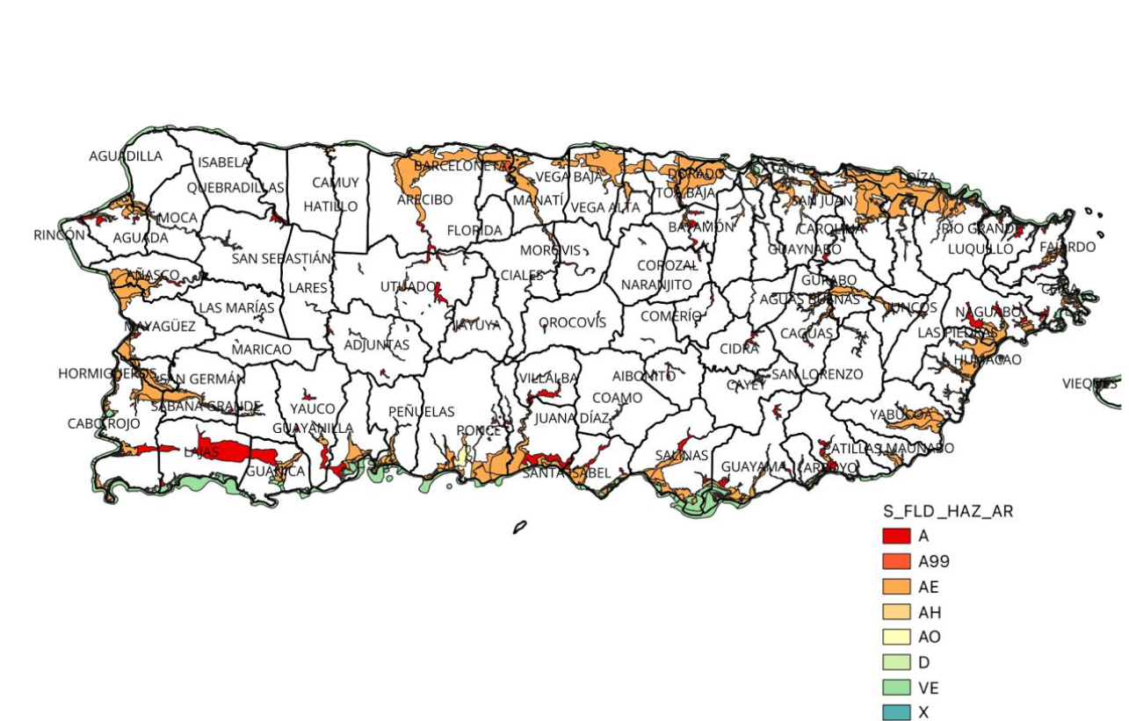

Figure ‑ Flood Hazard Zones

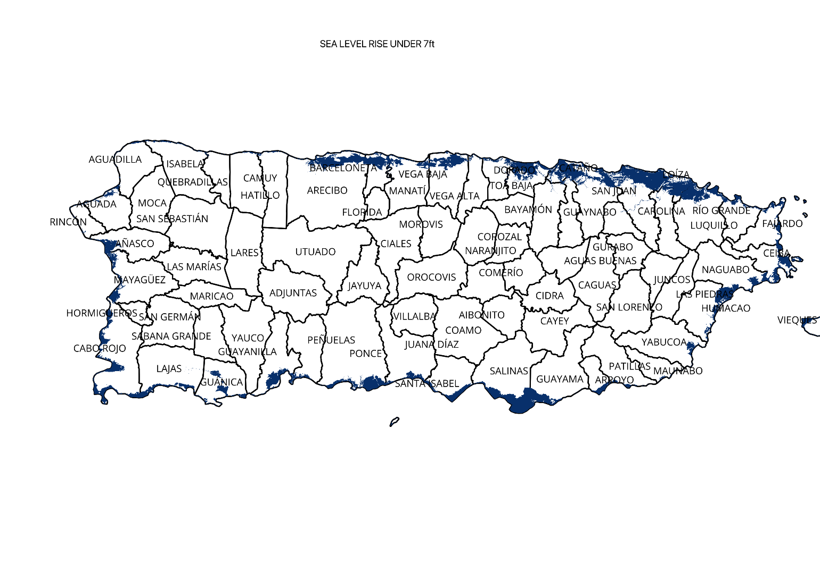

Figure ‑ Sea Level Rise (SLR) of 7-feet

Each field was carefully conditioned to ensure consistency, minimize errors, and support cross-layer analysis for dashboard and map generation.

## Data Context

The socio-demographic, housing, and economic data were derived from the American Community Survey (ACS) 5-Year Estimates (2017-2021), ensuring statistical stability and high-resolution granularity. Flood exposure data were obtained from FEMA Flood Insurance Rate Maps (FIRMs), while SLR exposure data were extracted from NOAA’s Sea Level Rise Viewer using the 6.8-foot inundation layer.

Facility locations were acquired from the Homeland Infrastructure Foundation-Level Data (HIFLD) and validated with supplemental datasets from the Puerto Rico Planning Board.

The spatial context involved aligning all layers to a common CRS (EPSG:32161 – Puerto Rico State Plane) to enable accurate geographic analysis and overlay operations.

## Data Conditioning

The datasets underwent several critical conditioning steps:

* **Null Value Handling:** Missing demographic or housing fields were imputed where feasible using block group medians.
* **Data Cleaning:** Non-numeric characters (e.g., commas in population fields) were removed to allow numeric calculations.
* **Spatial Clipping:** National FEMA flood zones and NOAA SLR raster data were clipped to the Puerto Rico boundary.
* **Exposure Metrics Derivation:** New fields such as AreaAffectedFlood, AreaAffectedSLR, PopAffectedFlood, and PopAffectedSLR were calculated by spatially intersecting exposure layers with block groups.
* **Normalization:** Variables for SOVI and VRS were normalized to a 0–1 scale for aggregation.
* **Validation:** Cross-checks ensured that area and population fields aligned appropriately with geographic extents.

## Data Quality Assessment

|  |  |
| --- | --- |
| **Attribute** | **Assessment** |
| Completeness | Most data is available at the municipality level, but some barrio-level data has missing values. We addressed this through imputation methods. |
| Uniqueness | Each record represents a specific geographic location, ensuring no duplicate entries. |
| Accuracy | Data is sourced from data.census.gov, a validated government source, but some fields have high margins of error, particularly in small communities. |
| Atomicity | Each field represents a single, well-defined variable with no mixed data types. |
| Conformity | The dataset follows U.S. Census Bureau standards, but some variables required formatting adjustments for consistency. |
| Overall Quality | While the data is highly reliable, additional validation with external sources (e.g., FEMA, NOAA) is needed to improve accuracy for flood-prone areas. |

By maintaining high data quality, we enhance the reliability of the SOVIARS vulnerability index, ensuring accurate risk assessments for climate adaptation planning.

## Other Data Sources

During the data collection process, we evaluated multiple external datasets but chose not to include some due to various limitations. Below are some considered but excluded datasets:

1. FEMA Community Resilience Indicators

* Why Considered? It provides social vulnerability metrics and community resilience scores.
* Why Excluded? The dataset lacks high-resolution, local-level data for Puerto Rico, making it less useful for detailed vulnerability assessment.

1. USGS Coastal Erosion Data

* Why Considered? It tracks shoreline changes and historical erosion patterns.
* Why Excluded? The data is incomplete for Puerto Rico and does not align well with our housing and socioeconomic variables.

1. CDC Social Vulnerability Index (SVI)

* Why Considered? It ranks communities based on social vulnerability indicators.
* Why Excluded? The dataset uses a national-scale ranking system, which does not provide the granular insights needed for Puerto Rico-specific assessments.

While these datasets were not included, they may be revisited in future iterations of the project if additional data validation or supplementary analysis is required.

## Storage Medium

For this project, the selected storage medium is a cloud-based data storage solution. Given the size and complexity of the datasets, cloud storage offers scalability, accessibility, and ease of collaboration. The team has opted to use Google Drive and GitHub for raw data storage and version control. Google Drive enables secure file storage and sharing among team members, while GitHub serves as a repository for structured and processed data, ensuring version tracking and reproducibility.

## Storage Security

Ensuring the security of stored data is critical for maintaining data integrity and confidentiality. Our storage security measures include:

* Access Control: Data access is restricted through role-based permissions, ensuring that only authorized team members can edit or download datasets.
* Encryption: Google Drive and Amazon S3 employ encryption protocols for data at rest and in transit, preventing unauthorized access.
* Version Control: GitHub provides version control, preventing accidental data loss or overwriting of critical information.
* Regular Backups: Cloud platforms offer automated backups, ensuring that data is not lost due to accidental deletion or corruption.

By implementing these security measures, we minimize risks associated with data breaches and unauthorized modifications.

## Storage Costs

Since all datasets were publicly available and cloud storage was provided via academic accounts, there were no additional costs incurred for data access or storage during the project.

# ALGORITHMS AND ANALYSIS

## ALGORITHMS

The SOVIARS index is a composite vulnerability score calculated by integrating two main components:

1. SOVI – Social Vulnerability Index
2. VRS – Vulnerability to Rising Seas

The final score is computed using a weighted sum, with greater emphasis placed on social vulnerability to reflect the human capacity dimension in climate adaptation.

1. **SOVI (Social Vulnerability Index)**

The SOVI component was adapted from the well-established SoVI® methodology by Cutter et al. (2003), using a subset of census-based variables relevant to Puerto Rico. These include:

* + Percent population over 65
  + Percent population under 5
  + Percent female-headed households
  + Percent renters
  + Percent households below poverty line
  + Unemployment rate
  + Educational attainment (no high school diploma)
  + Percent of population with disabilities
  + Housing without plumbing
  + Percent minority and non-English speakers

SOVI Steps:

Step 1: **Normalize all variables** to a 0–1 scale using min-max scaling.

Step 2: **Group Variables** into categories: demographic, housing, economic.

Step 3: Average the grouped variables to create sub-indexes.

Step 4: Aggregated sub-indexes to form a final SOVI score:

SOVI = $\frac{\left(0.20* Demographic\right)+\left(0.15 * Housing\right)+\left(0.30* Economic\right)+(0.35*Social)}{4}$

All values are calculated at the block group level.

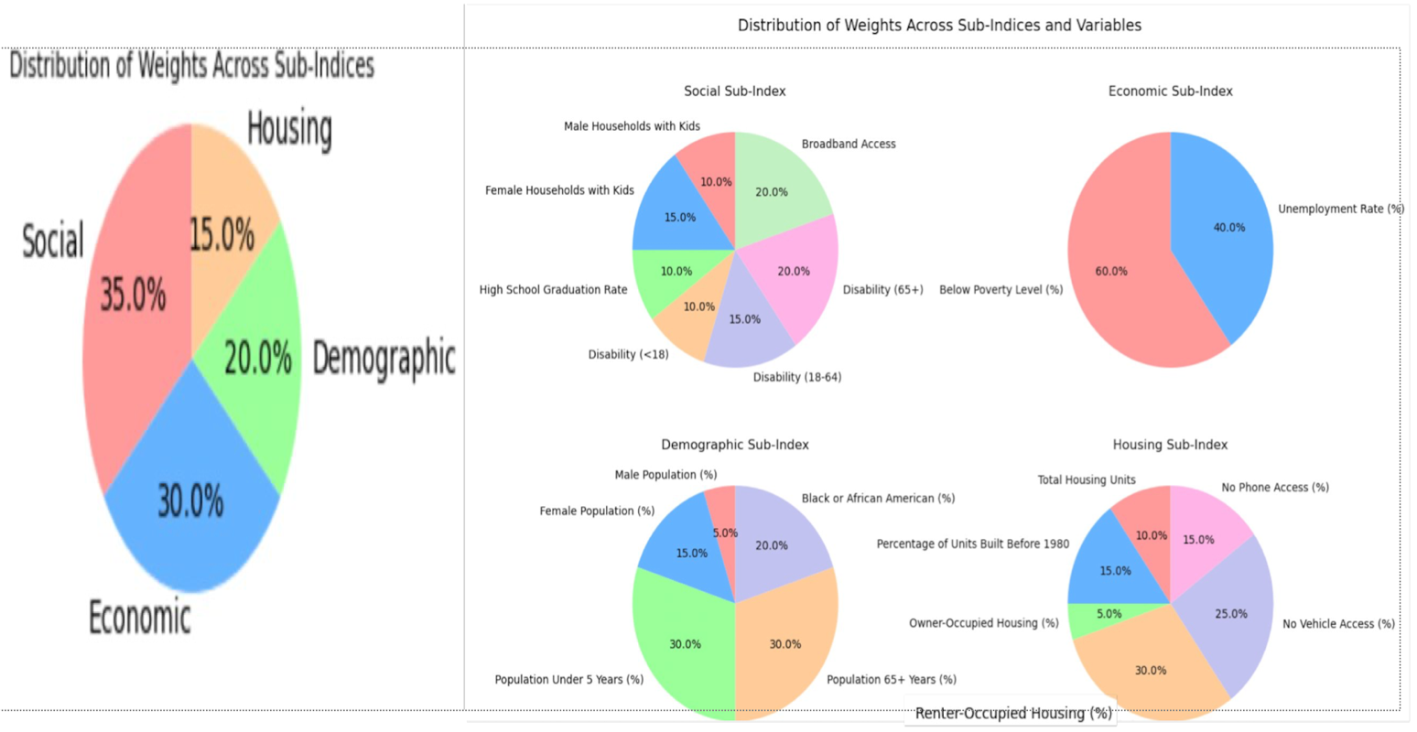

Figure ‑: Distribution of weights for sun-indices and weights for variables for each sub index

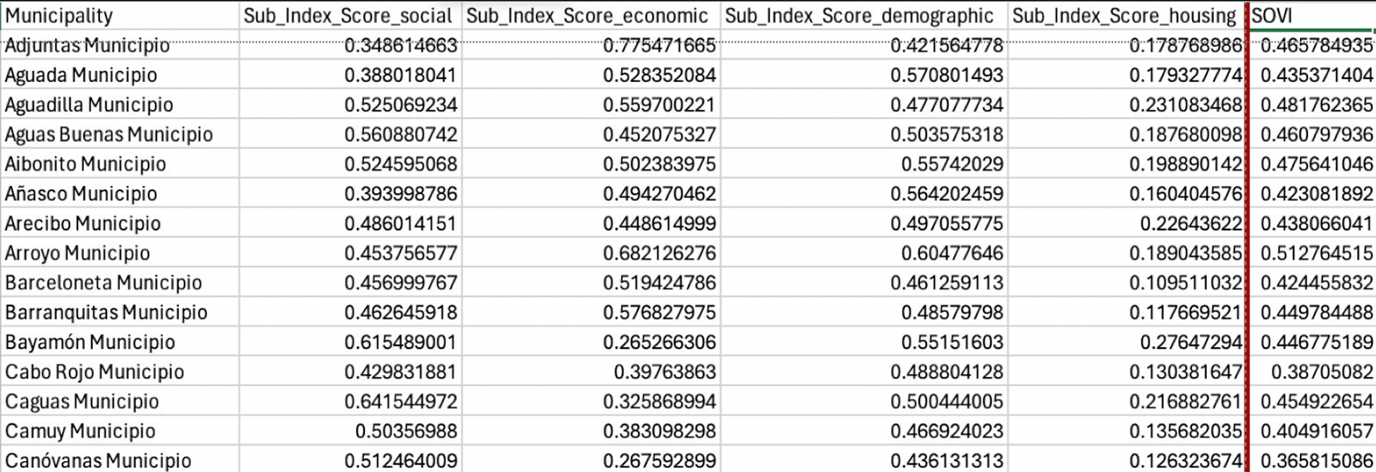

Figure ‑: Output snippet for the SOVI Index file

## VRS (Vulnerability for Rising Seas)

VRS quantifies geographic exposure to sea-level rise and flood hazards using:

* + Area Affected by Sea Level Rise
  + Population Affected by Sea Level Rise
  + Area Affected by FEMA Flood Zones
  + Population Affected by FEMA Flood Zones

Each metric is calculated as a proportion:

|  |  |
| --- | --- |
| AreaSLR = $\frac{AreaAffectedSLR}{ALAND}$ | PopSLR = $\frac{PopAffectedSLR}{Population}$ |
| AreaFlood = $\frac{AreaAffectedFlood}{ALAND}$ | PopFlood = $\frac{PopAffectedFlood}{Population}$ |

1. **Weight Assignment for VRS**

To derive meaningful weights for the four VRS fields, a hybrid approach was used:

1. Expert Elicitation via AHP (Analytic Hierarchy Process):

* Experts assigned greater weight to population exposure than geographic area.
* Initial weight estimates: PopSLR ~45%, PopFlood ~33%, AreaSLR ~15%, AreaFlood ~7%

2. Statistical Validation using PCA (Principal Component Analysis):

* PCA run on the four normalized exposure ratios.
* Loadings confirmed population metrics contributed most variance.

3. Final Combined Weights (after Sensitive Testing):

PopSLR = 0.44, PopFlood = 0.30, AreaSLR = 0.18, AreaFlood = 0.08

1. **VRS Formula**

The formula used to calculate the **VRS Index** is:

VRS = (0.44×%PerPopSLR) + (0.30 × %PerPopFlood) + (0.18 × %PerAreaSLR) + (0.08 × %PerAreaFlood)

This VRS value was normalized across all block groups to produce values from 0 (no exposure) to 1 (maximum exposure).

1. **Final SOVIARS Calculation**

The SOVIARS (Socioeconomic Vulnerability Index for Adaptation to Rising Seas) combines both social vulnerability and environmental exposure into a single score to help prioritize adaptation planning. The index assigns a 60% weight to SoVI (Social Vulnerability Index) and a 40% weight to VRS, balancing the needs of socially at-risk populations with physical environmental hazards.

The formula used to compute SOVIARS is:

SOVIARS = (0.6 × SoVI) + (0.4 × VRS)

This combined index helps stakeholders and policymakers pinpoint communities that require urgent and targeted adaptation strategies—whether through infrastructure investments, resource allocation, or social resilience programs.

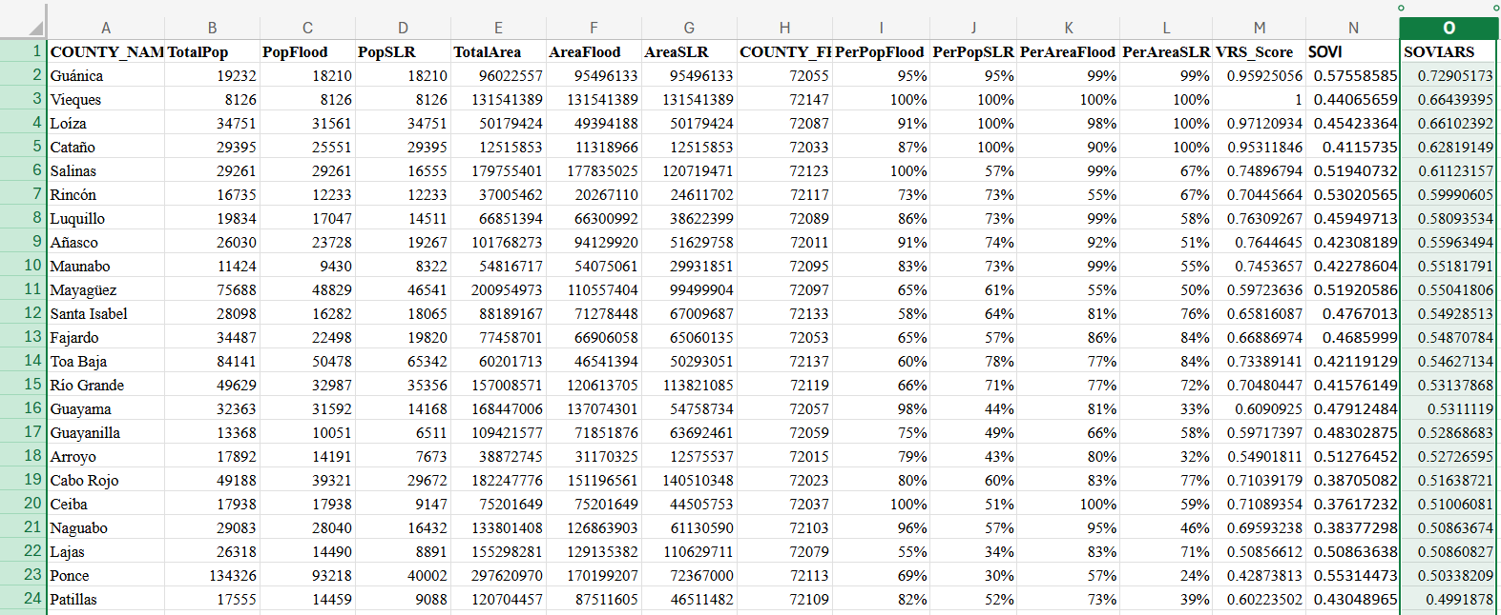

Figure ‑ Output for the final VRS and SOVIARS index scores

## ANALYSIS

The analytical process used both **spatial and statistical techniques:**

* **QGIS** was used for:
  + Spatial joins and intersections (e.g., flood zones with block groups)
  + Raster clipping of SLR elevation data
  + Creating population and area exposure fields
  + Mapping block groups and aggregating to municipality level

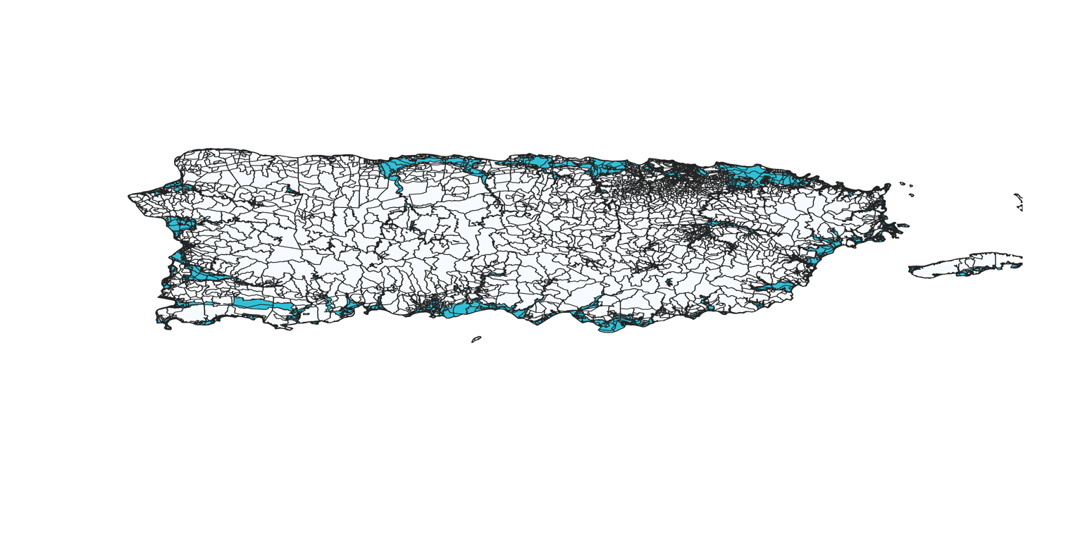

Figure ‑ Flood Exposure using QGIS (Block Group Level)

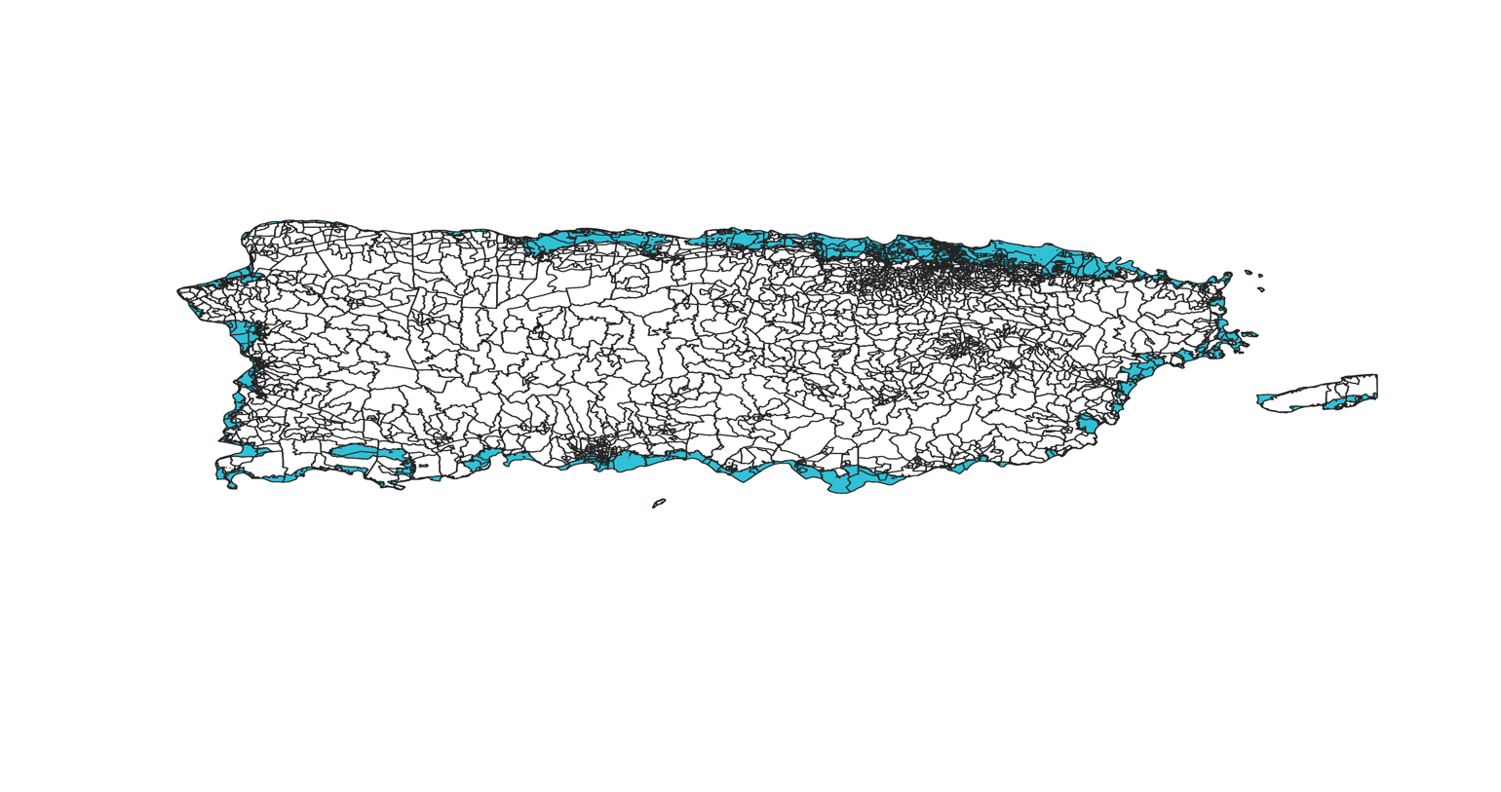

Figure ‑ Areas Exposed to Sea Level Rise (Block Group Level)

* Excel and Python were used for:
  + AHP matrix calculations
  + PCA validation of weight assumptions
  + Composite index calculations
* Dashboards were used for:
  + Visualize SOVI, VRS, and SOVIARS score interactively
  + Display facility-level risk and adaptation insights
  + Classify areas by adaptation strategies (e.g., high exposure + high social vulnerability)

This hybrid workflow enabled robust and interpretable modeling of climate vulnerability in Puerto Rico.

# VISUALIZATIONS

## VISUALIZATIONS

To effectively communicate the insights generated from the SOVIARS model, a suite of interactive and static visualizations was created using QGIS and Tableau. These visualizations aim to make the results accessible to diverse audiences — from policy makers to local stakeholders — by highlighting patterns of risk and vulnerability across Puerto Rico.

Each visualization was designed to emphasize different dimensions of vulnerability:

* **SOVI** (Social Vulnerability)
* **VRS** (Environmental Exposure)
* **SOVIARS** (Composite Risk)
* **Adaptation strategies**, based on risk category
* **Critical facility exposure**, identifying infrastructure priorities

## INTERPRETATIONS

### **SOVIARS Composite Map**

Type: Choropleth (Municipality Level)

Purpose: Displays the final SOVIARS score across all block groups in Puerto Rico

Color Scheme: Red Scale (Light Red = Low Risk, Dark Red = High Risk)

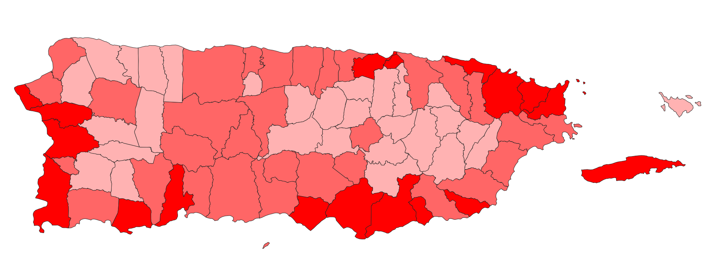

Figure ‑ SOVIARS Composite Map

Interpretation:  
The map reveals that coastal municipalities — particularly in the north and southwest — have the highest composite vulnerability due to the convergence of socioeconomic disadvantage and geographic exposure. This visualization enables immediate prioritization of areas for adaptation funding and infrastructure reinforcement.

### **SOVI vs. VRS Side-by-Side Maps**

Type: Dual Choropleth Maps

Purpose: Enables visual comparisons between social vulnerability and environmental exposure scores.

Color Scheme:

1. SOVI: Blue scale (Light = Low social vulnerability, Dark = High)
2. VRS: Orange scale (Light = Low exposure, Dark = High)

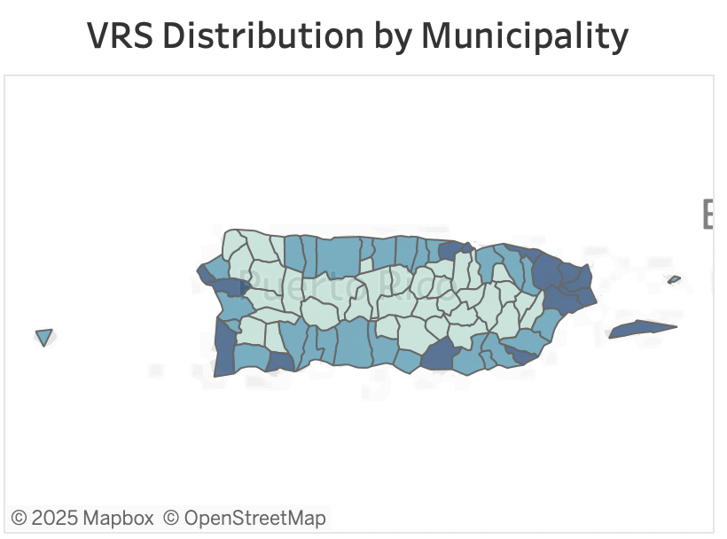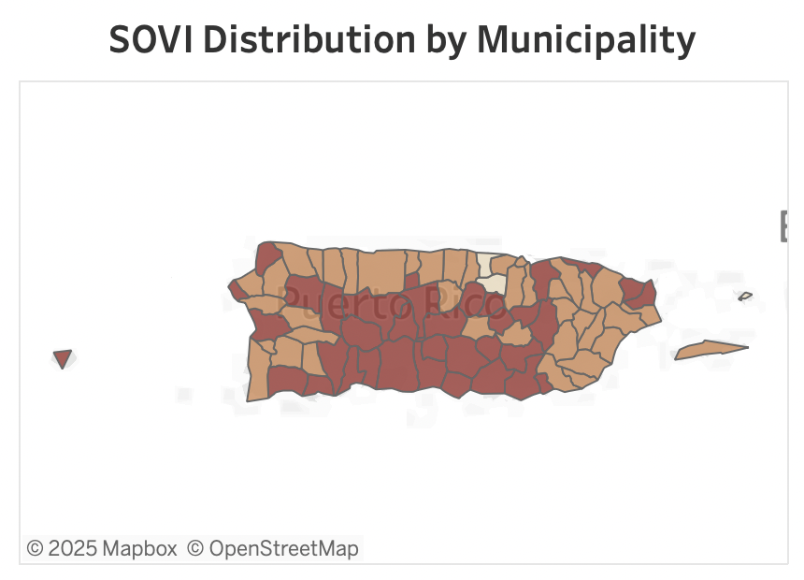

Figure ‑ VRS & SoVI Distribution by Municipality

Interpretation:

These maps show areas where social vulnerability is high but physical exposure is low, and vice versa – supporting nuanced policy decisions. For instance, inland urban areas with high SOVI but low flood exposure may still require investment in healthcare and economic resilience programs.

### **Top 10 Most Vulnerable Municipalities**

Type: Horizontal Bar Chart

Purpose: Ranks municipalities by average SOVIARS Score.

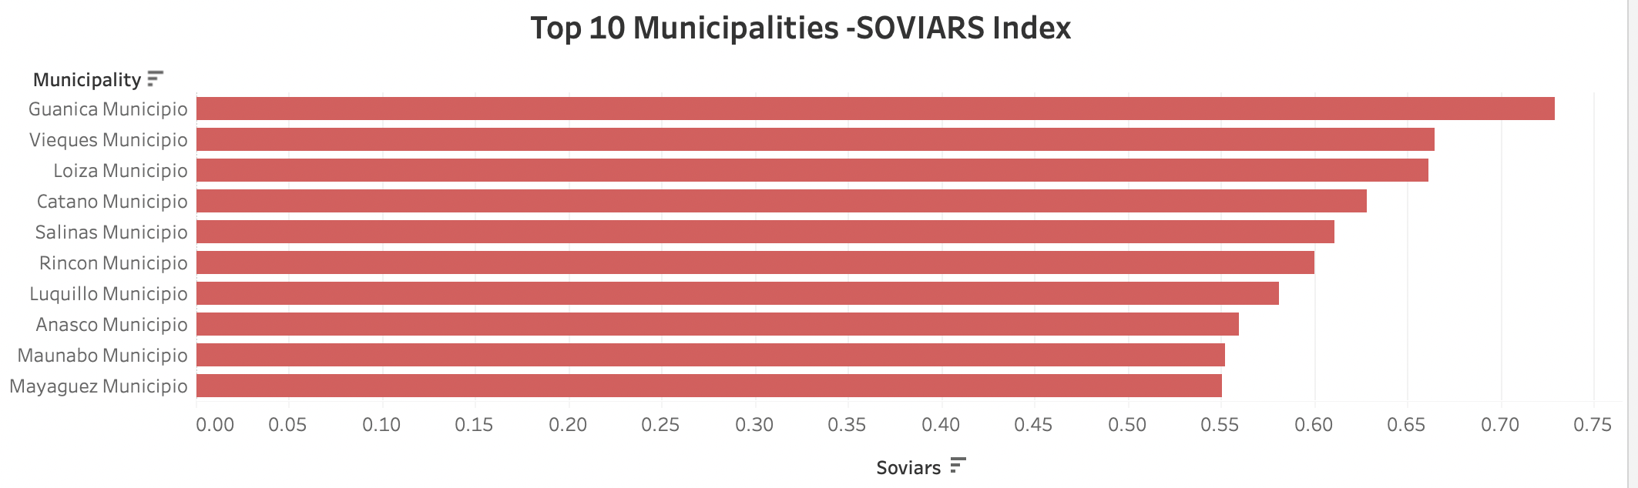

Figure ‑ Topmost Vulnerable Municipalities

Interpretation:

Enables high-level planning by showing which municipalities require urgent investment. Particularly useful for policy-level decision-makers and grant distribution.

### **Dashboard View: Risk Categorization + Adaptation Insight**

Type: Dashboard

Cards Displayed:

* SOVI Score
* VRS Score
* SOVIARS
* Risk Category
* Adaptation Recommendation

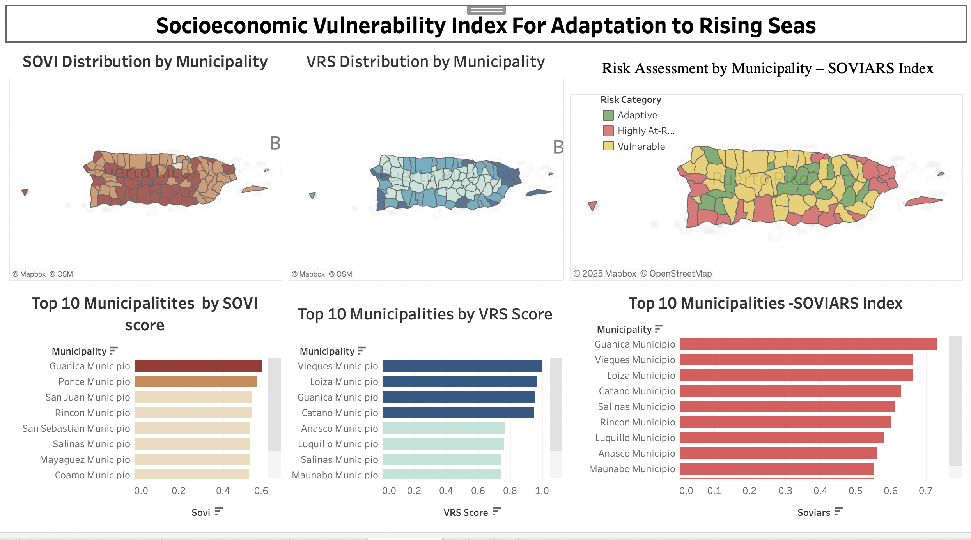

Figure ‑ SOVIARS Dashboard

Interpretation:

Provides a real-time, user-friendly way to browse regions and understand both the problem and the suggested solution in one glance. Particularly impactful for public communication.

# Findings

Our SOVIARS analysis revealed several key insights into the patterns of combined social and environmental vulnerability across Puerto Rico:

1. **High-Risk Hotspots Concentrated Along the Coast:**

Coastal municipalities—most notably San Juan, Loíza, Guayama, and Mayagüez—consistently ranked in the top quintile of our composite index. These areas not only experience the greatest physical exposure (both to projected 6.8-ft sea-level rise and FEMA-designated flood zones) but also exhibit elevated social vulnerability, including high poverty rates, housing cost burdens, and limited access to vehicles and broadband.

1. **Population Exposure Dominates Geographic Exposure:**

Although low-lying land area is an important factor, our weighting analysis (44% weight on Pop SLR; 30% on Pop Flood vs. 18% and 8% on area measures) showed that the number of people at risk is a stronger driver of our VRS score. In practical terms, densely populated barrios with moderate elevation are more vulnerable than sparsely inhabited, flood-prone tracts.

1. **Socioeconomic Disadvantage Amplifies Risk:**

When we overlay the VRS component with our Social Vulnerability Index (SOVI), we see that municipalities with similar physical exposure can display very different overall vulnerability profiles depending on their socioeconomic context. For example, Barceloneta and Arecibo—both exposed to flooding—rank higher on SOVIARS due to lower median incomes and higher percentages of renters and single-parent households.

1. **Data Gaps in Critical Infrastructure and Resilience Metrics:**

During our spatial joins, we found limited geocoded data on community resilience assets (e.g., shelters, clinics, emergency hubs) and on coastal erosion rates at the barrio level. These gaps prevented us from explicitly quantifying infrastructure vulnerability and social capital, suggesting priority areas for future data collection.

1. **Robustness Across Scenarios:**

Our sensitivity analysis—varying each VRS weight by ±10%—showed that the top 10 highest-risk municipalities remained unchanged. This stability indicates that our composite index reliably identifies priority areas, even under reasonable uncertainty about exact weight values.

# Summary

In this project, we developed the Socioeconomic Vulnerability Index for Adaptation to Rising Seas (SOVIARS) to help Puerto Rico’s policymakers and planners allocate resources equitably. We started by assembling four domains of social vulnerability (social, economic, demographic, housing) and four measures of geographic exposure (area and population affected by both sea-level rise and flood zones). After rigorous data cleaning, normalization, and weight derivation—combining expert input via AHP, statistical validation with PCA, and sensitivity testing—we computed sub-indices and merged them into a single SOVIARS score.

Our findings pinpointed the most vulnerable communities, revealed the primacy of population exposure over land-area measures, and highlighted how socioeconomic disadvantage exacerbates flood risk. The final SOVIARS index, weighted 60% social vulnerability and 40% environmental exposure, provides a transparent, reproducible metric ranging from 0 (lowest vulnerability) to 1 (highest). Interactive dashboards and choropleth maps developed in QGIS and Excel make these insights accessible to non-technical stakeholders.

Ultimately, SOVIARS bridges the gap between raw data and actionable adaptation strategies, ensuring that the communities most at risk—both physically and socioeconomically—are prioritized in future resilience investments.

# Future Work

To enhance and extend the SOVIARS framework, we recommend the following next steps:

1. Integrate Dynamic Climate Projections:

Incorporate time-series inundation models (e.g., 2030, 2050, 2100) from NOAA and local sea-level rise scenarios to capture evolving hazards and enable planning for near- and long-term adaptation.

1. Enrich Infrastructure and Resilience Metrics:

Compile location data for critical facilities—hospitals, schools, shelters, power and water stations—and overlay them with our vulnerability layers to assess direct impacts on essential services.

1. Incorporate Community Resilience Indicators:

Develop social capital metrics (e.g., civic engagement, nonprofit networks) through surveys or proxy data (e.g., membership in local organizations) to refine the Social Vulnerability Index.

1. Automate Data Updates and Versioning:

Deploy an automated pipeline (e.g., Python scripts on GitHub Actions) that periodically pulls the latest Census estimates, FEMA flood maps, and elevation data, recalculates the index, and publishes updated dashboards.

1. Engage Stakeholders in Participatory Validation:

Host workshops with community leaders and emergency managers to ground-truth the index results, gather feedback on weightings, and co-design targeted adaptation policies.

1. Expand to Other Hazard Types:

Extend the framework to include hurricane wind zones, storm-surge projections, and erosion rates, enabling a multidimensional assessment of climate hazards beyond sea-level rise.

By pursuing these enhancements, the SOVIARS tool will evolve into a comprehensive, adaptive decision-support system—one that remains current, inclusive, and directly aligned with Puerto Rico’s changing climate resilience needs.

**This page intentionally left blank**

Appendix

Appendix A: Domain Background

**1. Understanding Climate Vulnerability**

Climate change is increasing the frequency and intensity of environmental hazards around the world. Sea-level rise, in particular, is one of the most critical threats facing low-lying coastal regions and island territories. As oceans warm and glaciers melt, global sea levels are rising at an accelerating pace. The Intergovernmental Panel on Climate Change (IPCC) estimates a global mean sea-level rise between 0.29 and 1.1 meters by 2100, depending on emission scenarios.[1]

While the physical impacts of sea-level rise — like coastal erosion, flooding, and saltwater intrusion — are widely studied, the human impacts are often more complex and less visible. Not all communities are affected equally. A region’s adaptive capacity — its ability to prepare for, absorb, and recover from environmental events — varies significantly across populations. This disparity has led researchers and practitioners to shift toward a more holistic approach to climate risk, one that incorporates both physical exposure and social vulnerability.

**2. The Puerto Rico Context**

Puerto Rico is a U.S. territory located in the Caribbean with a population of over 3 million people. Its geography makes it highly susceptible to hurricanes, storm surges, and long-term sea-level rise. Over 60% of its population lives within 10 kilometers of the coast, and many critical facilities — such as hospitals, power plants, and emergency shelters — are located in flood-prone areas.

Beyond environmental risk, Puerto Rico also faces a host of socioeconomic challenges:

* Roughly 43% of the population lives below the poverty line [2]
* Aging infrastructure and declining public investment
* Ongoing recovery from Hurricanes Maria (2017) and Fiona (2022)
* Net population loss due to migration and economic uncertainty

These conditions reduce the island’s resilience to climate threats. For example, in the aftermath of Hurricane Maria, it took months to restore power and critical services — a delay partly due to the intersection of fragile infrastructure and social inequality.

**3. Defining Vulnerability**

In the context of climate risk, vulnerability is defined as the degree to which a system is susceptible to, and unable to cope with, adverse effects of climate change. According to the IPCC, vulnerability is a function of:

* Exposure – the extent to which a system is physically located in a hazard-prone area
* Sensitivity – how severely the system is affected
* Adaptive Capacity – the ability to adjust or recover

**4. Why Composite Indices Are Needed**

Traditional climate planning tools — such as FEMA flood maps — are excellent at showing physical risk, but they do not capture social conditions. A household living 500 meters inland in an affluent area may be far more resilient to disruption than a coastal neighborhood with poor drainage, fragile housing, and low income.

To solve this, researchers have developed composite indices that combine social and environmental data. One widely cited model is the Social Vulnerability Index (SoVI) created by Cutter et al. [3], which uses census variables like income, age, housing type, and education to estimate how well a community can absorb and recover from disasters.

These models have been used in mainland U.S. contexts, but until now, no such composite vulnerability index existed specifically for Puerto Rico — especially one that emphasized both socioeconomic conditions and sea-level exposure.

**5. Introducing SOVIARS: A Puerto Rico-Focused Index**

This project introduces the Socioeconomic Vulnerability Index for Adaptation to Rising Seas (SOVIARS) — a tool designed to help Puerto Rican planners, municipalities, and communities visualize and respond to risk.

SOVIARS is built from two components:

* SOVI: A custom Social Vulnerability Index based on Puerto Rico’s ACS data
* VRS: A Vulnerability to Rising Seas score using FEMA flood zones and NOAA SLR projections

The final score is a weighted combination of these two factors:

$$SOVIARS=(0.6*SOVI)+(0.4*VRS)$$

This formula reflects the prioritization of social capacity over pure physical exposure — a key value of this project.

**6. Public Accessibility and Dashboard Use**

To bridge the gap between complex analytics and real-world decisions, the team built an interactive dashboard. This tool visualizes:

* SOVIARS scores by block group and municipality
* Exposure of facilities like hospitals and schools
* Custom adaptation recommendations based on risk categories



Figure ‑ SOVIARS Dashboard View

The dashboard is designed to be accessible to:

* Policy makers
* Emergency managers
* Community organizations
* The general public

By combining clarity and rigor, it empowers decision-makers with both the “where” and the “why” behind climate vulnerability in Puerto Rico.

**7. Broader Implications**

SOVIARS is not just a one-off tool for this project — it’s a model that can be:

* Scaled to other U.S. Island territories or coastal counties
* Updated as new census or climate data become available
* Expanded to include health metrics, infrastructure resilience, or real-time hazard feeds

This aligns with national priorities from FEMA, NOAA, and HUD to prioritize equity, resilience, and data-driven planning in climate adaptation.

**8. Summary**

In summary, this domain background explains the urgency, frameworks, and innovation that led to the creation of SOVIARS. As climate risks escalate, tools like SOVIARS provide a path forward — not just to measure vulnerability, but to build resilience where it’s needed most.

**References (IEEE Style)**

1. IPCC, “Summary for Policymakers,” Climate Change 2021: The Physical Science Basis, 2021.
2. U.S. Census Bureau, “ACS 5-Year Estimates, 2021.”
3. Cutter, S. L., Boruff, B. J., & Shirley, W. L., “Social vulnerability to environmental hazards,” Social Science Quarterly, vol. 84, no. 2, pp. 242–261, 2003.

Appendix B: Glossary

|  |  |
| --- | --- |
| Term | Definition |
| SOVI (Social Vulnerability Index) | A composite metric that captures a communityâ€™s ability to prepare for, respond to, and recover from disasters, based on social, economic, and housing factors. |
| VRS (Vulnerability to Rising Seas) | A calculated score representing geographic and population-level exposure to FEMA-designated flood zones and projected sea-level rise inundation areas. |
| SOVIARS | The final vulnerability score derived from a weighted combination of SOVI (60%) and VRS (40%), designed to assess overall climate risk at the block group level. |
| Exposure | The extent to which a population, infrastructure, or region is physically located in a hazard-prone area (e.g., flood zones, low-elevation coastal zones). |
| Adaptive Capacity | The ability of a community to adjust to climate impacts, moderate potential damage, and recover quickly after a disaster. |
| Flood Zones (FEMA) | Areas designated by the Federal Emergency Management Agency as having a 1% annual chance of flooding (also known as the 100-year floodplain). |
| SLR (Sea-Level Rise) | The increase in average sea levels caused primarily by global warming and melting ice sheets, leading to permanent inundation of low-lying areas. |
| AHP (Analytic Hierarchy Process) | A structured decision-making method used to determine weights for multiple factors through pairwise comparisons, often based on expert input. |
| PCA (Principal Component Analysis) | A statistical method used to reduce dimensionality and identify the most important contributing variables in a dataset. |
| Choropleth Map | A thematic map where areas are shaded or colored in proportion to the value of a statistical variable, such as a vulnerability score. |
| Dashboard | An interactive digital interface used to visualize and interpret data, often combining maps, charts, and logic-based insights. |

Table 1: Glossary Table

Appendix C: GitHub Repository

**Overview**

The GitHub repository for this project contains the complete project pipeline — including source code, spatial analysis workflows, visualizations, and documentation. It supports reproducibility, version control, and public access to results.

**GitHub Repository Link**

<https://github.com/Narra03/Team_SOVIARS_DAEN-690_10.git>

**GitHub Repository Contents**

|  |  |
| --- | --- |
| Folder/File | Description |
| DATA/ | Cleaned and merged datasets used in SOVI, VRS, and SOVIARS calculations. |
| Documentation/ | Methodology, formulas, adaptation logic, and project notes. |
| Code and output files | Python scripts, Excel calculations, and PCA/AHP tools used in analysis. |
| MAIN_PROJECT.qgz | QGIS project file containing spatial joins, styling, and all final map layers. |
| README.md | Project overview, folder structure, and instructions for navigating the repo. |

Appendix D: Risks

Sprint 1 Risks

|  |  |  |  |  |
| --- | --- | --- | --- | --- |
| Risk | Description | Probability | Impact | Mitigation |
| Incomplete Census or Facility Data | Initial datasets lacked some critical block group or facility records | High | High | Supplement with secondary sources and validate with spatial joins |
| Projection Mismatch in QGIS | Spatial layers had different CRS projections, causing alignment errors | Medium | Medium | Standardized all data to EPSG:32161 early in the sprint |
| Confusion over SLR thresholds | No clear guidance on which sea-level rise scenario to use | Medium | Medium | Considered NOAA guidance and selected a 6.8-ft scenario to align with risk maps |

Table 2: Sprint 1 Risks

Sprint 2 Risks

|  |  |  |  |  |
| --- | --- | --- | --- | --- |
| Risk | Description | Probability | Impact | Mitigation |
| Missing or imprecise facility coordinates | Some facilities lacked geolocation info or had incorrect formattting | High | Medium | Geocoded manually using OSM and confirmed locations with base maps |
| Complex exposure calculations | Difficulty calculating % population exposed due to mixed field types | Medium | High | Cleaned and converted all population fields into numeric formats |
| Dashboard overcomplexity | Attempting to display too many layers and filters in Tableau | Medium | Medium | Streamlined dashboard into focused tabs for end-user clarity |

Table 3: Sprint 2 Risks

Sprint 3 Risks

|  |  |  |  |  |
| --- | --- | --- | --- | --- |
| Risk | Description | Probability | Impact | Mitigation |
| Weight selection uncertainty | AHP weight values were subjective and potentially biased | Medium | Medium | Validated with PCA to ensure statistical reliability |
| Overlap between flood and SLR zones | Confusion in handling duplicate exposure in overlapping regions | Medium | High | Created binary exposure logic and intersection fields |
| Slow processing in QGIS with large rasters | SLR raster operations slowed down system performed | High | Low | Clipped raster to study area before processing |

Table 4: Sprint 3 Risks

Sprint 4 Risks

|  |  |  |  |  |
| --- | --- | --- | --- | --- |
| Risk | Description | Probability | Impact | Mitigation |
| Mislabeling adaptation logic outputs | Complex nested IF logic led to wrong messages in some cases | Medium | Medium | Added visual logic flowchart and automated validation rows |
| Missing values in calculated exposure fields | Some block groups had nulls in denominator columns | High | Medium | Added safeguards (e.g., if Population = 0 then set exposure = 0) |
| Communication lag in dashboard edits | Misalignment between data updates and Tableau refreshes | Medium | Low | Used shared folders and naming conventions for real-time file updates |

Table 5: Sprint 4 Risks

Sprint 5 Risks

|  |  |  |  |  |
| --- | --- | --- | --- | --- |
| Risk | Description | Probability | Impact | Mitigation |
| Visual legend misinterpretation | Users misunderstood what map colors meant in dashboards | Medium | Medium | Simplified legends, added titles and tooltips |
| Column naming confusion | Long column names in merged Excel files caused Tableau import errors | Medium | Low | Renamed and mapped fields with a standard convention |
| Last-minute formatting for submission | Differences in Word template formatting across members’ devices | Medium | Low | Consolidated final editing in one master document |

Table 6: Sprint 5 Risks

Appendix E: Agile Development

Scrum Framework Team Approach

Figure 8‑2: Sprint project dates.

The SOVIARS project was developed using the Agile Scrum framework, which allowed the team to iteratively plan, develop, and refine deliverables over the course of five sprints. Weekly stand-ups, sprint reviews, and retrospectives helped the team stay on track, prioritize tasks, and adjust based on feedback from the instructor and stakeholders.

Team Roles:

* Scrum Master: Facilitated sprint planning, managed team velocity, resolved blockers, and ensured team adherence to Agile principles.
* Product Owner: Defined project goals, prioritized the backlog, ensured stakeholder needs were reflected in development decisions, and validated outputs.
* Developers (4): Collaboratively worked on data preprocessing, QGIS spatial analysis, Excel-based exposure modeling, Tableau dashboards, and report writing.

This lean and cross-functional structure enabled agile coordination across data, spatial, and visualization tasks — with shared responsibility and continuous communication.

Sprint 1 Lessons Learned

* Aligning on the project vision early helped streamline all technical decisions.
* Standardizing the coordinate system (CRS) was essential to avoid issues in QGIS later.
* Missing or incomplete census and flood data emphasized the need for early validation and backups.

Sprint 2 Lessons Learned

* Team members adapted quickly to unfamiliar tools like QGIS and Tableau, showing strong flexibility.
* Coordination between spatial analysis (QGIS) and dashboard development (Tableau) was improved by using shared folders and naming conventions.
* Manual data cleanup, especially for population and facility fields, was more time-intensive than expected — early assignment of that task would have helped.

Sprint 3 Lessons Learned

* Developing the exposure calculations using both population and area required constant communication between the GIS and modeling roles.
* Pairing subjective (AHP) and objective (PCA) weighting approaches gave credibility to our final vulnerability model.
* Clipping rasters and exposure zones in QGIS taught us how to optimize geospatial workflows.

Sprint 4 Lessons Learned

* Adapting technical output for non-technical audiences required simplifying dashboard logic and legend explanations.
* We learned the importance of automated logic validation to catch minor errors in adaptation messaging.
* Setting field conventions across Excel and Tableau reduced redundancy and import issues.

Sprint 5 Lessons Learned

* Consolidating editing into a single shared final document prevented versioning problems.
* Final visualization tweaks — including color schemes, legends, and tooltips — improved public communication and stakeholder readability.
* The entire team became more confident presenting technical work in non-technical formats (dashboards, summaries, etc.).

References

[1] A. R. Crimmins et al., Chapter 9: Coastal Effects, Fifth National Climate Assessment, U.S. Global Change Research Program, 2023. [Online]. Available: https://doi.org/10.7930/NCA5.2023.CH23

[2] S. L. Cutter, B. J. Boruff, and W. L. Shirley, “Social vulnerability to environmental hazards,” Social Science Quarterly, vol. 84, no. 2, pp. 242–261, 2003. [Online]. Available: https://doi.org/10.1111/1540-6237.8402002

[3] U.S. Census Bureau, “American Community Survey (ACS) 5-Year Data (2017–2021),” 2022. [Online]. Available: https://www.census.gov/programs-surveys/acs

[4] NOAA Office for Coastal Management, “Sea Level Rise Viewer,” National Oceanic and Atmospheric Administration, 2022. [Online]. Available: https://coast.noaa.gov/slr

[5] Federal Emergency Management Agency (FEMA), “Flood Insurance Rate Maps (FIRMs),” 2021. [Online]. Available: https://msc.fema.gov/portal/home

[6] Puerto Rico Planning Board, Puerto Rico Hazard Mitigation Plan Update, 2020. [Online]. Available: https://www.mitigacionpr.com

[7] B. E. Flanagan, E. W. Gregory, E. J. Hallisey, J. L. Heitgerd, and B. Lewis, “A social vulnerability index for disaster management,” Journal of Homeland Security and Emergency Management, vol. 8, no. 1, 2011. [Online]. Available: https://doi.org/10.2202/1547-7355.1792

[8] U.S. Geological Survey (USGS), “3DEP Elevation Data Products and Services,” 2022. [Online]. Available: https://www.usgs.gov/core-science-systems/ngp/3dep

[9] Homeland Infrastructure Foundation-Level Data (HIFLD), “Puerto Rico Critical Facilities Dataset,” 2023. [Online]. Available: https://hifld-geoplatform.opendata.arcgis.com

[10] European Environment Agency, “Climate change impacts and vulnerability in Europe 2020,” 2020. [Online]. Available: https://www.eea.europa.eu/publications/climate-impacts-and-vulnerability-2020

[11] Puerto Rico Climate Change Council (PRCCC), *Puerto Rico’s State of the Climate: Assessing Social-Ecological Vulnerabilities*, 2022. [Online]. Available: <https://www.pr-ccc.org>

**This page intentionally left blank**